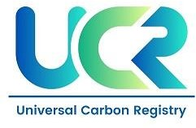

PROJECT CONCEPT NOTE
CARBON OFFSET UNIT (CoU) PROJECT

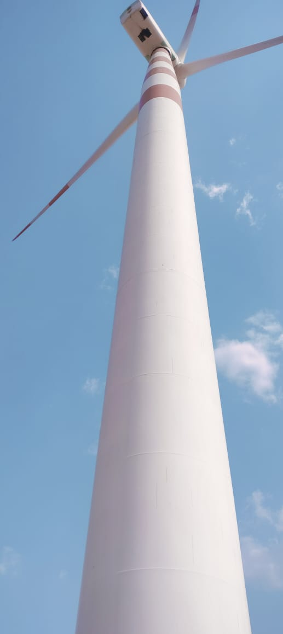
Title: 19.5 MW WIND POWER PROJECT IN RAJASTHAN BY LEAP GREEN ENERGY PVT LTD

Version 1.0 Date: 05/06/2024
First CoU Issuance Period: 8 Years, 4 Months
01/09/2015 to 31/12/2023

Project Concept Note (PCN) CARBON OFFSET UNIT (CoU) PROJECT
BASIC INFORMATION
Title of the project activity | 19.5 MW WIND POWER PROJECT IN RAJASTHAN BY LEAP GREEN ENERGY PVT LTD
Scale of the project activity | Large Scale Project
Completion date of the PCN | 05/06/2024
Project participants | LEAP GREEN ENERGY PRIVATE LIMITED
Host Party | India
Applied methodologies and standardized baselines | CDM UNFCCC Methodology  ACM0002: Grid connected electricity generation from renewable sources- Version 21.0
Sectoral scopes | 01 Energy industries  (Renewable/Non-Renewable Sources)
Estimated amount of total GHG emission reductions in 09 years, 03 months | To be estimated during verification.  An ex-ante estimate is 253,660 CoUs (253,660) tCO2eq

SECTION A. Description of project activity
A.1. Purpose and general description of Carbon offset Unit (CoU) project activity >>

The Project "19.5 MW Wind Power Project in Rajasthan by Leap Green Energy Pvt Ltd" is a wind-based power generation facility comprising 15 wind turbines across four villages located in the Jaipur district of the state of Rajasthan. It has been operational since October 29, 2010, which is the earliest commissioning date. The project is owned by Leap Green Energy Private Limited (hereinafter referred to as the Project Proponent or PP).

Purpose of the project activity:

The purpose of the project activity is to utilize renewable wind energy for generation of electricity. The project activity replaces anthropogenic emissions of greenhouse gases (GHG’s) into the atmosphere, by displacing the equivalent amount of electricity generation through the operation of existing fuel fossil fuel- based power plants and future capacity expansions connected to the grid. In the absence of the project activity the equivalent amount of electricity would have been generated from the fossil fuel-based power plant. Whereas the electricity generation from operation of Wind Energy Convertors (WEC) is emission free. Commissioning dates of the Wind Turbine Generator installed are shown in the below table:

Sr. No. | Make | No. & Capacity | Commissioning Date
1 | Suzlon | 2 X 1.25 MW | 04/12/2010
2 | Suzlon | 3 X 1.25 MW | 30/10/2010
3 | Suzlon | 7 X 1.25 MW  3 X 1.5 MW | 29/09/2010  30/09/2010

The project will generate approximately 28,185.30 MWh of electricity per annum. The net generated electricity from the project activity is for selling it to RDPPC by the project proponent. A Power Purchase Agreement is signed between PP and RDPPC. The project activity has been helping in greenhouse gas (GHG) emission reduction by using renewable resources (wind energy) for generating power which otherwise would have been generated using grid mix power plants, which is dominated by fossil fuel based thermal power plants. The estimated annual average and the total CO2e emission reduction by the project activity is expected to be 25,366 t/CO2e & 253,660 t/CO2e respectively, whereas actual emission reduction achieved during the first CoU period shall be submitted as a part of first monitoring and verification.

A.2 Do no harm or Impact test of the project activity>>

There are social, environmental, economic and technological benefits which contribute to sustainable development.

Social benefits:
- The project activity will lead to the development of supporting infrastructure such as road network etc., in the wind park location, the access to which is also provided to the local population.
- The project activity will lead to alleviation of poverty by establishing direct and indirect benefits through employment generation and improved economic activities by strengthening of local grid of the state electricity utility.
- Use of a renewable source of energy reduces the dependence on imported fossil fuels and associated price variation thereby leading to increased energy security.

Environmental benefits:
- The project activity employs renewable energy source for electricity generation instead of fossil fuel- based electricity generation which would have emitted gaseous, liquid and/or solid effluents/wastes.
- Being a renewable resource, using wind energy to generate electricity contributes to resource conservation. Thus, the project causes no negative impact on the surrounding environment and contributes to environmental well-being.

Economic benefits:
- The project activity requires temporary and permanent, skilled and semi-skilled manpower at the wind park; this will create additional employment opportunities in the region.
- The generated electricity will be fed into the NEWNE regional grid through local grid, thereby improving the grid frequency and availability of electricity to the local consumers (villagers & sub- urban habitants) which will provide new opportunities for industries and economic activities to be setup in the area thereby resulting in greater local employment, ultimately leading to overall development.

Technical benefits:
- Increased interest in wind energy projects will further push R&D efforts by technology providers to develop more efficient and better machinery in future.

United Nations Sustainable Development Goals:

The project activity generates electrical power using wind energy, which is generated from windmills, thereby displacing non-renewable fossil resources resulting to sustainable, economic and environmental development. In the absence of the project activity equivalent amount of power generation would have taken place through fossil fuel dominated power generating stations. Thus, the renewable energy generation from project activity will result in reduction of the greenhouse gas emissions.

SDG Goals | Description
Goal 2 | This project activity promotes good health by providing daily essentials to the local people in the vicinity of the project activity.
Goal 4 | This Project activity promotes educational amenities that can directly and indirectly help students achieve quality or better education.  Also Support underprivileged or rural schools with required and unlocked various opportunities for school children.
Goal 6 | This project activity installed RO water system to provide clean water to the local community. This sustainable solution ensures every person has access to safe drinking water.
Goal 8 | This project activity generates additional employment in the operations and maintenance of the wind farm for the local people.  This project will achieve full and productive employment and decent work.
Goal 13 | This 19.5 MW wind power project meets the SDG 13 goal by displacing fossil fuel with clean energy. This project is expected to reduce 25,366 tCO₂ emission per year.

A.3. Location of project activity >>

As the windmills are installed in 4 different locations of Rajasthan state, the locations are mentioned in tabular form.

Village | Installed Capacity | District | State
Sirwa | 5000kW | Jaisalmer | Rajasthan
Sangana | 4500kW | Jaisalmer | Rajasthan
Moda | 7500kW | Jaisalmer | Rajasthan
Chord | 2500kW | Jaisalmer | Rajasthan

The representative Location of map is included below:
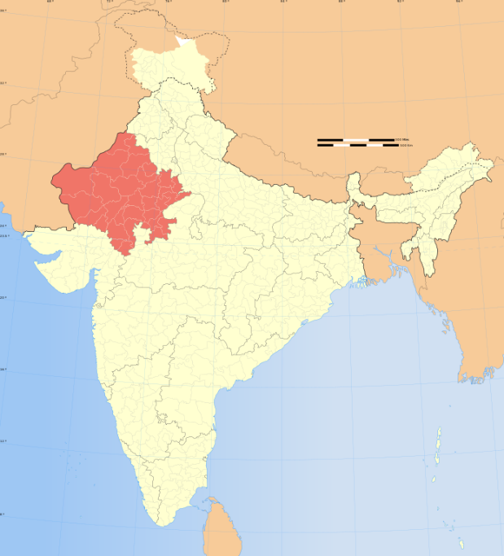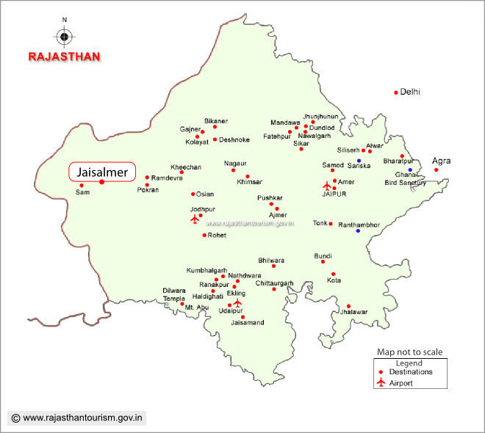
Rajasthan
Project Activity

The project is located at Sangana, Sirwa, Moda, and Chord village in Jaisalmer district of Rajasthan state, India. In Sirwa windmills of capacity 2 x1.25 MW are installed. In Sangana, Sirwa, Moda & Chord windmill of capacity (3 x 1.5) MW & (7 x 1.25) are installed. In Sangana, Sirwa, Moda & Chord windmills of capacity 3 X 1.25 MW are installed.

The following table shows the WEG numbers for all the wind turbines:

Loc No | Site Name | WEG | Wind turbine capacity | capacity in kW
 |  | No
AK 16 |  | 473139 | 1250 kw
AK25 | Sirwa site | 64273398 | 1250 kw | 2500
AK26 |  | 64260371 | 1250 kw
AK15 |  | 64255991 | 1250 kw
AK33 |  | 64263586 | 1250 kw
AK35 |  | 64263586 | 1250 kw
AK36 | Sangana, Sirwa, Chicha, Modha & Chord | 64261003 | 1250 kw | 13250
AK37 |  | 64258610 | 1250 kw
AK249 |  | 51510081 | 1500kw
AK279 |  | 51510076 | 1500kw
AK408 |  | 51510059 | 1500kw
AK223 |  | 64256300 | 1250 kw
AK30 |  | 64274769 | 1250 kw
Ak31 | Sangana, Sirwa, Moda & Chord | 64270858 | 1250 kw | 3750
AK32 |  | 64263584 | 1250 kw
 |  |  |  | 19,500kw

Latitudes and longitudes of each site are mentioned in table below:

LOCNO | Make | Site | Capacity | Village | Latitude | Longitude
AK249 | Suzlon | Akal | 1500 | Sangana | 26.80342 | 71.115722
AK279 | Suzlon | Akal | 1500 | Sangana | 26.80147 | 71.132583
AK408 | Suzlon | Akal | 1500 | Sangana | 26.78594 | 71.110167
AK223 | Suzlon | Akal | 1250 | Chord | 26.76533 | 71.137806
AK30 | Suzlon | Akal | 1250 | Chord | 26.70306 | 71.102083
AK31 | Suzlon | Akal | 1250 | Moda | 26.70006 | 71.104361
AK32 | Suzlon | Akal | 1250 | Moda | 26.69747 | 71.106583
AK33 | Suzlon | Akal | 1250 | Moda | 26.69317 | 71.109056
AK26 | Suzlon | Akal | 1250 | Sirwa | 26.68842 | 71.100056
AK35 | Suzlon | Akal | 1250 | Moda | 26.68886 | 71.115833
AK36 | Suzlon | Akal | 1250 | Moda | 26.68636 | 71.117194
AK25 | Suzlon | Akal | 1250 | Sirwa | 26.68 | 71.106806
AK37 | Suzlon | Akal | 1250 | Moda | 26.68203 | 71.117917
AK16 | Suzlon | Akal | 1250 | Sirwa | 26.66081 | 71.090639
AK15 | Suzlon | Akal | 1250 | Sirwa | 26.65869 | 71.094722

A.4. Technologies/measures >>
The bundled project activity consists of multiple Wind turbines of 1500 kW, 1250 kW respectively manufactured and supplied by Suzlon. This project Generate 19.5 MW power which is consumed by customers delivered by the Grid.

Main component of the windmill is explained below:

Main Tower
This is a very tall structure with a door and inside ladder at the bottom. The door is used to enter into the tower for operation and maintenance.

Blades
The windmills are provided with three blades. The blades are self-supporting in nature made up of Fibre Reinforced Polyester. The blades are mounted on the hub.

Nacelle
The Nacelle is the one which contains all the major parts of a windmill. The nacelle is made up of thick rugged steel and mounted on a heavy slewing ring. Under normal operating conditions, the nacelle would be facing the upstream wind direction.

Hub
The Hub is an intermediate assembly between the wing and the main shaft of the wind turbine. Inside the hub, a system to actuate the aerodynamic brake is fitted. The hub is covered with nose cone.

Main Shaft
The shaft connects the gear box and the hub. Solid high carbon steel bars or cylinders are used as main shaft. The shaft is supported by two bearings.

Some of the salient features of the project equipment can be found in the below mentioned table.

MODEL | S66-1250kW | S82-1500kW
OPERATING DATA
Rated power | 1250 kW | 1,500 kW
Cut-in wind speed | 3 m/s | 4 m/s
Rated wind speed | 14 m/s | 12 m/s
Cut-off wind speed | 22 m/s | 20 m/s
Survival wind speed | 52.5 m/s | 52.5 m/s
ROTOR
Type | 3 Blades, Upwind/Horizontal axis | 3 Blades, Upwind/Horizontal axis
Diameter | 66 m | 82 m
Rotational speed at rated power | 13.5 to 20.3 rpm | 15.6 to 16.3 rpm
Rotor blade material | Epoxy bonded fiber glass | Epoxy bonded fiberglass
Swept area | 3421 m² | 5,281 m²
Power regulation | Active pitch regulated | Active pitch regulation
GEARBOX
Nominal load | 1390 kW | 1,650 kW
Type of cooling | Forced oil cooling lubrication system | Forced oil cooling lubrication system
GENERATOR
Type | Dual speed induction generator (asynchronous) | Induction generator with slip rings,  variable rotor resistances via  Suzlon Flexi
Speed at rated power | 1506 rpm | 1,511 rpm
Rated voltage | 690 V AC (phase to phase) | 690 V AC (phase to phase)
Frequency | 50 Hz | 50 Hz
Insulation | Class H | Class H
TOWER
Tower height | 63 m | 76.1 m
Hub height (including foundation) | 65 m | 76.8 m

A.5. Parties and project participants >>

Party (Host) | Participants
India | LEAP GREEN ENERGY PRIVATE LIMITED

A.6. Baseline Emissions>>

The baseline scenario identified at the PCN stage of the project activity is:

In the absence of the project activity, the equivalent amount of electricity would have been generated from fossil fuel-based power plants and exported to the regional grid (which is connected to the unified Indian Grid system) as national grid is predominantly sourcing from fossil fuel-based power plants. Hence, baseline scenario of the project activity is the grid-based electricity system, which is also the pre-project scenario.

Schematic diagram showing the baseline scenario:

Baseline Scenario:

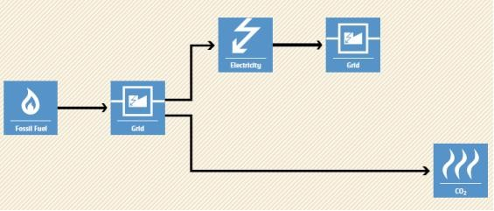

Project Scenario:
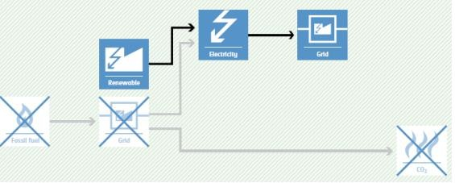

A.7. Debundling>>
This project is not a debundled component of a larger registered carbon offset project activity.

SECTION B. Application of methodologies and standardized baselines

B.1. References to methodologies and standardized baselines >>

SECTORAL SCOPE – 01 Energy industries (Renewable/Non-renewable sources)

TYPE I- Renewable Energy Projects

CATEGORY- ACM0002.: “Grid connected electricity generation from renewable sources- Version 21.0.”

B.2. Applicability of methodologies and standardized baselines >>
The project activity involves generation of grid connected electricity from the construction and operation of a new wind power-based power project for selling it to grid. The project activity has an installed capacity of 19.5 MW which will qualify for a large-scale project activity. The project status corresponds to the methodology ACM0002, and applicability of methodology is discussed below.

Applicability Criteria. | Project Case
1)This methodology is applicable to grid-connected renewable energy power generation project activities that:  (a) Install a Greenfield power plant;  (b) Involve a capacity addition to (an) existing plant(s);  (c) Involve a retrofit of (an) existing operating plant(s)/unit(s);  (d) Involve a rehabilitation of (an) existing plant(s)/unit(s); or (e) Involve a replacement of (an) existing plant(s)/unit(s). | The proposed project activity is a green field Plant, that is to connected Grid.  Therefore, the project activity satisfies the point (a).
2) In case the project activity involves the integration of a BESS, the methodology is applicable to grid-connected renewable energy power generation project activities that:  (a)Integrate BESS with a Greenfield power plant;  (b) Integrate a BESS together with implementing a capacity addition to (an) existing solar photovoltaic1 or wind power plant(s)/unit(s);  (c) Integrate a BESS to (an) existing solar photovoltaic or wind power plant(s)/unit(s) without implementing any other changes to the existing plant(s);  (d) Integrate a BESS together with implementing a retrofit of (an) existing solar photovoltaic or wind power plant(s)/unit(s). | The project activity is the installation of 19.5 MW Wind power project and does not involve the integration of a Battery Energy Storage System (BESS). This condition is not applicable for this project.
3)The methodology is applicable under the following conditions:  (a) Hydro power plant/unit with or without reservoir, wind power plant/unit, geothermal power plant/unit, solar power plant/unit, wave power plant/unit or tidal power plant/unit;  (b) In the case of capacity additions, retrofits, rehabilitations or replacements (except for wind, solar, wave or tidal power capacity addition projects) the existing plant/unit started commercial operation prior to the start of a minimum historical reference period of five years, used for the calculation of baseline emissions and defined in the baseline emission section, and no capacity expansion, retrofit, or rehabilitation of the plant/unit has been undertaken between the start of this minimum historical reference period and the implementation of the project activity;  (c) In case of Greenfield project activities applicable under paragraph 5 (a) above, the project participants shall demonstrate that the BESS was an integral part of the design of the renewable energy project activity (e.g. by referring to feasibility studies or investment decision documents);  (d) The BESS should be charged with electricity generated from the associated renewable energy power plant(s). Only during exigencies 2 may the BESS be charged with electricity from the grid or a fossil fuel electricity generator. In such cases, the corresponding GHG emissions shall be accounted for as project  emissions following the requirements under section 5.4.4 below. The charging using the grid or using fossil fuel electricity generator should not amount to more than 2 per cent of the electricity generated by the project renewable energy plant during a monitoring period. During the time periods (e.g. week(s), months(s)) when the BESS consumes more than 2 per cent of the electricity for charging, the project participant shall not be entitled to issuance of the certified emission reductions for the concerned periods of the monitoring period. | The proposed project activity is the installation of a new Wind power plants without BESS integration. Therefore, the said criterion is not applicable
4)In case of hydro power plants, one of the following conditions shall apply:  a)The project activity is implemented in an existing single or multiple reservoirs, with no change in the volume of any of reservoirs; or  b)The project activity is implemented in an existing single or multiple reservoirs, where the volume of the reservoir(s) is increased and the power density calculated using equation (7) is greater than 4 W/m2; or  c)The project activity results in new single or multiple reservoirs and the power density calculate equation (7), is greater than 4 W/m2.  d)The project activity is an integrated hydro power project involving multiple reservoirs, where the power density of any of the reservoirs, calculated using equation (7), is lower than or equal to 4 W/m2, all of the following conditions shall apply.  i)The power density calculated using the total installed capacity of the integrated project, as per equation (8) is greater than 4W/m2;  ii)Water flow between reservoirs is not used by any other hydropower unit which is not a part of the project activity;  Installed capacity of the power plant(s) with power density lower than or equal to 4 W/m2shall be:  Lower than or equal to 15 MW; and  Less than 10% of the total  iii) installed capacity of integrated hydro power project | The proposed project activity is the installation of Wind power plants/units. Therefore, the said condition is not applicable.
5)In the case of integrated hydro power projects, project proponent shall:  a) Demonstrate that water flow from upstream power plants/units spill directly to the downstream reservoir and that collectively constitute to the generation capacity of the integrated hydro power project; or  b) Provide an analysis of the water balance covering the water fed to power units, with all possible combinations of reservoirs and without the construction of reservoirs. The purpose of water balance is to demonstrate the requirement of specific combination of reservoirs constructed under CDM project activity for the optimization of power output. This demonstration has to be carried out in the specific scenario of water availability indifferent seasons to optimize the water flow at the inlet of power units. Therefore, this water balance will take into account seasonal flows from river, tributaries (if any), and rainfall for minimum five years prior to implementation of CDM project activity. | The proposed project activity is the installation of a wind power plants/units. Therefore, the said criteria is not applicable
6)The methodology is not applicable to:  a) Project activities that involve switching from fossil fuels to renewable energy sources at the site of the project activity, since in this case the baseline may be the continued use of fossil fuels at the site.  b) Biomass fired power plants; | The proposed project activity is Greenfield wind power project and does not fall under any of the options (a) (b) (c). Therefore, the said criteria is not applicable.
7)In the case of retrofits, rehabilitations, replacements, or capacity additions, this methodology is only applicable if the most plausible baseline scenario, as a result of the identification of baseline scenario, is “the continuation of the current situation, that is to use the power generation equipment that was already in use prior to the implementation of the project activity and undertaking business as usual maintenance | The proposed project activity is the installation of wind power plants. Therefore, the said criteria is not applicable.
B.3. Applicability of double counting emission reductions >>

There is no double accounting of emission reductions in the project activity due to the following reasons:

- Project is uniquely identifiable based on its location coordinates,
- Project has dedicated commissioning certificate and connection point,
- Project is associated with energy meters which are dedicated to the consumption point for project developer.

As per applicable methodology, the spatial extent of the project boundary includes the project power plant and all power plants connected physically to the electricity system that the project power plant is connected to. Hence, the project boundary includes the project site where the power plant has been installed, associated power evacuation infrastructure, energy metering points, switch yards and other civil constructs and connected to the regional grid of Rajasthan.
B.4. Project boundary, sources, and greenhouse gases (GHGs)>>
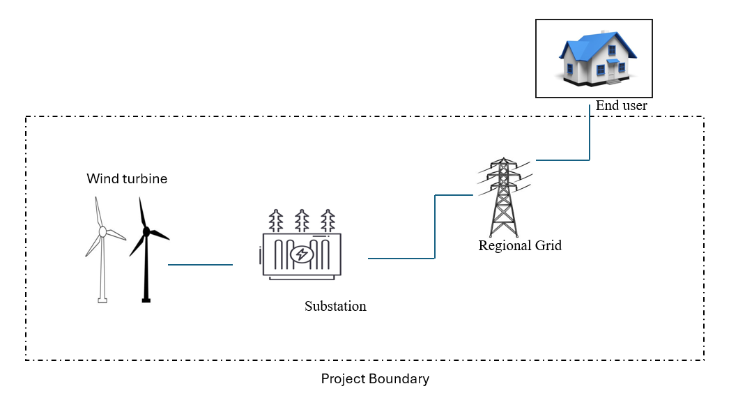

Thus, the project boundary includes the Wind Turbine Generator (WTG) and the Indian grid system.

Source |  | Gas | Included? | Justification/Explanation
Baseline | Grid connected electricity generation | CO₂ | Yes | Main Emission Source
 |  | CH₄ | No | Minor Emission Source
 |  | N₂O | No | Minor Emission Source
 |  | Other | No | No other GHG emissions were emitted from the project
Project | Greenfield Wind Power Project Activity | CO₂ | Yes | No CO₂ emissions are emitted from the project
 |  | CH₄ | No | Project activity does not emit CH₄
 |  | N₂O | No | Project activity does not emit N₂O
 |  | Other | No | No other emissions are emitted from the project

B.5. Establishment and description of baseline scenario) >>

As per the approved consolidated methodology ACM0002. Version-21, if the project activity is the installation of a new grid-connected renewable power plant, the baseline scenario is the following: “The baseline scenario is that the electricity delivered to the grid by the project activity would have otherwise been generated by the operation of grid-connected power plants and by the addition of new generation sources into the grid”.

The project activity involves setting up a new wind power plant to harness the green power from wind energy and sell it to the grid by signing a PPA. In the absence of the project activity, the equivalent amount of power would have been supplied by the Indian grid, which is fed mainly by fossil fuel fired plants. The power produced at grid from the other conventional sources which are predominantly fossil fuel based. Hence, the baseline for the project activity is the equivalent amount of power produced at the Indian grid.

A "grid emission factor" refers to a CO2 emission factor (tCO2/MWh) which will be associated with each unit of electricity provided by an electricity system. The UCR recommends an emission factor of 0.9 tCO2/MWh for the 2013-2023 years as a conservative estimate for Indian projects not previously verified under any GHG program. Also, for the vintage 2021, the combined margin emission factor calculated from CEA database in India results into higher emission than the default value. Hence, the same emission factor has been considered to calculate the emission reduction under conservative approach.

- Emission reductions are calculated as follows:

𝐸𝑅y= 𝐵𝐸y− 𝑃𝐸y− 𝐿𝐸y (Eq. 1)

Where,
𝐸𝑅y = Emissions reductions in year y (t CO2)
𝐵𝐸y = Baseline emissions in year y (t CO2)
𝑃𝐸y = Project emissions in year y (t CO2)
𝐿𝐸y = Leakage emissions in year y (t CO2)

Baseline Emissions
Baseline emissions include only CO2 emissions from electricity generation in power plants that are displaced due to the project activity. The methodology assumes that all project electricity generation above baseline levels would have been generated by existing grid-connected power plants and the addition of new grid-connected power plants.

  - The Baseline emissions in year y can be calculated as follows:

𝐵𝐸y = 𝐸𝐺PJ,y × 𝐸𝐹Grid,y, (Eq. 2)

Where,
𝐵𝐸y = Baseline emissions in year y (t CO2)
𝐸𝐺PJ,y = Quantity of net electricity generation that is produced and fedinto the grid as a result of the implementation of the CDM project activity in year y (MWh)
𝐸𝐹Grid,y = Grid emission factor in year y (t CO2/MWh)

Project Emissions
As per Paragraph 35, Version21.0 only emission associated with fossil fuel combustion. Since the project activity is a wind power project, project emission for renewable energy plant is nil.
Thus,
PE_{y} = 0 (Eq. 3)

Leakage Emissions
In the project activity, there is no transfer of energy generating equipment and therefore the leakage from the project activity is considered as zero which is accordingly to Paragraph 39, Version 2.
Thus,
LE_{y} = 0 (Eq. 4)

Estimated Annual or Total baseline emission reductions (BEy) = CoUs /year (25,366 tCO2eq/year)

The actual emission reduction achieved during the first CoU period shall be submitted as a part of first monitoring and verification. However, for the purpose of an ex-ante estimation, following calculation has been submitted:

Estimated annual baseline emission reductions (BEy) = 28,185.30MWh/year × 0.9 tCO₂/MWh = 25,366 tCO2eq/year.

Year | Net Generation | Baseline Emissions | Project | Leakage | Emission
 |  |  | Emissions | Emission | Reductions
 | MWh | (tCO₂e) | (tCO₂e) | (tCO₂e) | (tCO₂e)
Year 1 | 28,185.30 | 25,366 | 0 | 0 | 25,366
Year 2 | 28,185.30 | 25,366 | 0 | 0 | 25,366
Year 3 | 28,185.30 | 25,366 | 0 | 0 | 25,366
Year 4 | 28,185.30 | 25,366 | 0 | 0 | 25,366
Year 5 | 28,185.30 | 25,366 | 0 | 0 | 25,366
Year 6 | 28,185.30 | 25,366 | 0 | 0 | 25,366
Year 7 | 28,185.30 | 25,366 | 0 | 0 | 25,366
Year 8 | 28,185.30 | 25,366 | 0 | 0 | 25,366
Year 9 | 28,185.30 | 25,366 | 0 | 0 | 25,366
Year 10 | 28,185.30 | 25,366 | 0 | 0 | 25,366
Total Emission reduction | 2,81,853.00 | 2,53,660 | 0 | 0 | 2,53,660
Annual Average ER | 28,185.30 | 25,366 |  |  | 25,366

B.6. Prior History>>

The project activity is a large-scale wind power project, and this project was never applied under any other GHG mechanism prior to this registration with UCR. Also, the capacity or the total project has not been applied for any other environmental crediting or certification mechanism. Hence the project will not cause double accounting of carbon credits (i.e., COUs).

B.7. Changes to start date of crediting period >>
The start date of the crediting period is considered from 01/09/2015 (The date from the legal ownership of the Project Participant).
B.8. Permanent changes from PCN monitoring plan, applied methodology or applied standardized baseline >>

There are no permanent changes from the registered PCN monitoring plan and applied methodology.

B.9. Monitoring period number and duration>>

First Issuance Period : 8 years 4 Months
Crediting Period : 01/09/2015 to 31/12/2025
Monitoring Period : 01/09/2015 to 31/12/2023
B.10. Monitoring plan>>

Data and Parameters available at validation (ex-ante values):

Data / Parameter | 𝐸𝐹Grid,y
Data unit | tCO2 /MWh
Description | A "grid emission factor" refers to a CO2 emission factor (tCO2/MWh) which will be associated with each unit of electricity provided by an electricity system. The UCR recommends an emission factor of 0.9 tCO2/MWh for the 2013 - 2020 years as a fairly conservative estimate for Indian projects not previously verified under any GHG program. Hence, the same emission factor has been considered to calculate the  emission reduction under conservative approach.
Source of data | https://a23e347601d72166dcd6-16da518ed3035d35cf0439f1cdf449c9.ssl.cf2.rackcdn.com//Documents/UCRCoUStandardAug2022updatedVer6_090822220127104470.pdf
Value applied | 0.9
Measurement methods  and procedures | -
Monitoring frequency | Ex-ante fixed parameter
Purpose of Data | For the calculation of Emission Factor of the grid

Data and Parameters to be monitored.

Data / Parameter | EG_{y, net}
Data unit | MWh
Description | Net electricity supplied to the NEWNE grid facility by the project activity.
Source of data | Joint Meter Reading Report
Measurement procedures (if any): | Data Type: Measured  Monitoring equipment: Energy Meters are used for monitoring Archiving Policy: Electronic  Calibration frequency: Once in 5 years (considered as per provision of CEA India).  The net electricity generated by the project activity will be calculated.
Measurement  Frequency: | Monthly
QA/QC procedures applied: | Continuous monitoring, hourly measurement monthly recording. Tri-vector (TVM)/ABT energy meters with accuracy class 0.2s.
Purpose of data: | The Data/Parameter is required to calculate the baseline emission.
Value applied: | To be applied as per actual data
QA/QC procedures applied: | Calibration of the Main meters will be carried out once in five (5) years as per National Standards (as per the provision of CEA, India) and faulty meters will be duly replaced immediately as per the provision of power purchase agreement.  Cross Checking:  Quantity of net electricity supplied to the grid will be cross checked from the invoices raised by the project participant to the grid.
Purpose of data: | Calculation of baseline emission.

